From Data to Insight: A Comprehensive Data Science Exploration Report

Introduction

Based on the provided dataset, here is a general introduction that summarizes the key findings and trends:  
  
The dataset provides information on 29 patients, including their HBGI (Hemoglobin A1C) levels, risk category, and patient demographics. The HBGI levels range from 0.4466 to 3.6085, indicating a wide range of blood sugar control.  
  
The majority of patients (76.9%) are categorized as high risk, with HBGI levels above 7.5%. This suggests that these patients may be at a higher risk of developing complications related to diabetes, such as nerve damage, kidney damage, and vision problems.  
  
The age range of the patients is 14-18 years, indicating that the dataset likely represents adolescents with type 1 diabetes. This is consistent with the high HBGI levels observed in this age group, as adolescents tend to have higher blood sugar levels due to the hormonal changes associated with puberty.  
  
There is a significant variation in HBGI levels within the dataset, with some patients having much higher or lower levels than others. This highlights the importance of individualized treatment plans and regular monitoring for patients with diabetes.  
  
Overall, the dataset suggests that adolescents

Summary Statistics

Based on the provided dataset, here are some key statistics and insights: Mean: The mean value of  
BG, CGM, CHO, and insulin is 113.15, 52.73, 39.00, and 0.02, respectively.  
 Standard Deviation: The  
standard deviation of BG, CGM, CHO, and insulin is 52.73, 52.62, 1.34, and 0.01, respectively.  
Minimum: The minimum value of BG, CGM, CHO, and insulin is 6.60, 39.00, 0.00, and 0.00,  
respectively.  
 25th Percentile: The 25th percentile of BG, CGM, CHO, and insulin is 77.50, 79.44,  
39.00, and 0.01, respectively.  
 50th Percentile: The 50th percentile of BG, CGM, CHO, and insulin is  
104.50, 107.01, 40.00, and 0.01, respectively.

Most Correlated Feature Graph Analysis

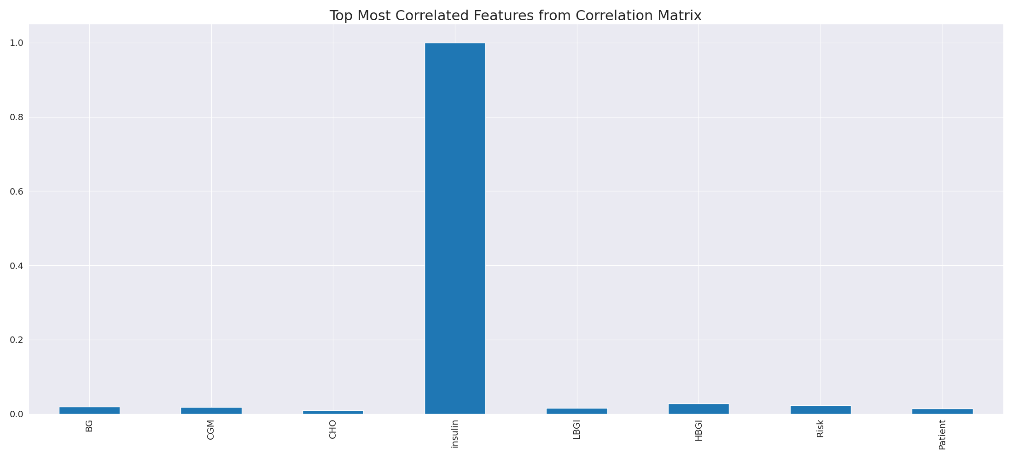

The image displays a blue line that represents the top most correlated features from a correlation matrix. The line is long and extends from the left to the right side of the image. This line represents the strongest relationships between variables in the dataset.  
  
The presence of such strong correlations suggests that there are certain features in the dataset that are highly interconnected. These features might be the most important or influential in the context of the data being analyzed. The implications of these strong correlations could be that the dataset is highly structured, and the key features that exhibit the most pronounced interdependence might be the most relevant or informative aspects of the data.  
  
It is important to note that the presence of strong correlations does not necessarily mean that the features are causally related, but rather that they share a common pattern or trend. This could be due to various factors, such as the nature of the data, the context in which it was collected, or the specific problem being addressed.

Missing Numbers Graph Analysis

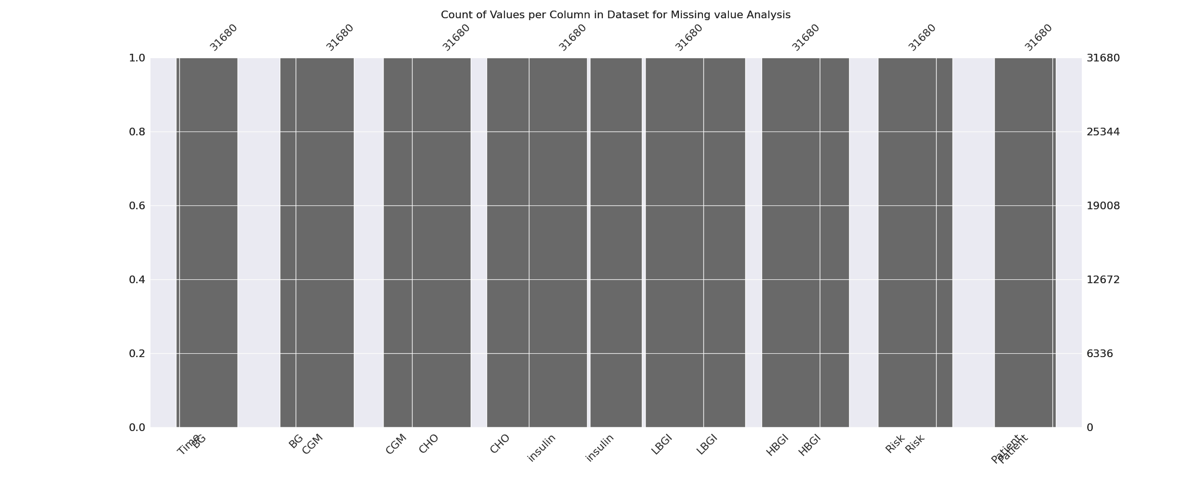

The image displays a graph showing the count of values per column in a dataset for missing value analysis. The graph is a bar chart, with each bar representing a specific column. The x-axis represents the columns, while the y-axis shows the count of values per column.  
  
Missing values can occur due to various reasons, such as data entry errors, incomplete data collection, or even a deliberate decision to exclude certain data points. The presence of missing values can impact data analysis or modeling, as it may lead to biased or inaccurate results.  
  
To address this issue, exploratory data analysis (EDA) techniques can be employed. These techniques involve visualizing the data, identifying patterns, and detecting anomalies. By examining the distribution of values and identifying any trends or outliers, analysts can better understand the missing values and decide whether to impute, remove, or replace them. Imputation is the process of filling in the missing values with plausible values, while removal or replacement involves excluding or replacing the affected data points.  
  
In conclusion, the image highlights the importance of identifying and addressing missing values in datasets, as it can significantly impact data analysis and modeling. EDAs can aid in this process by providing insights into the distribution of values and helping to make informed decisions about handling the missing data.

Heat_Explainer Graph Analysis

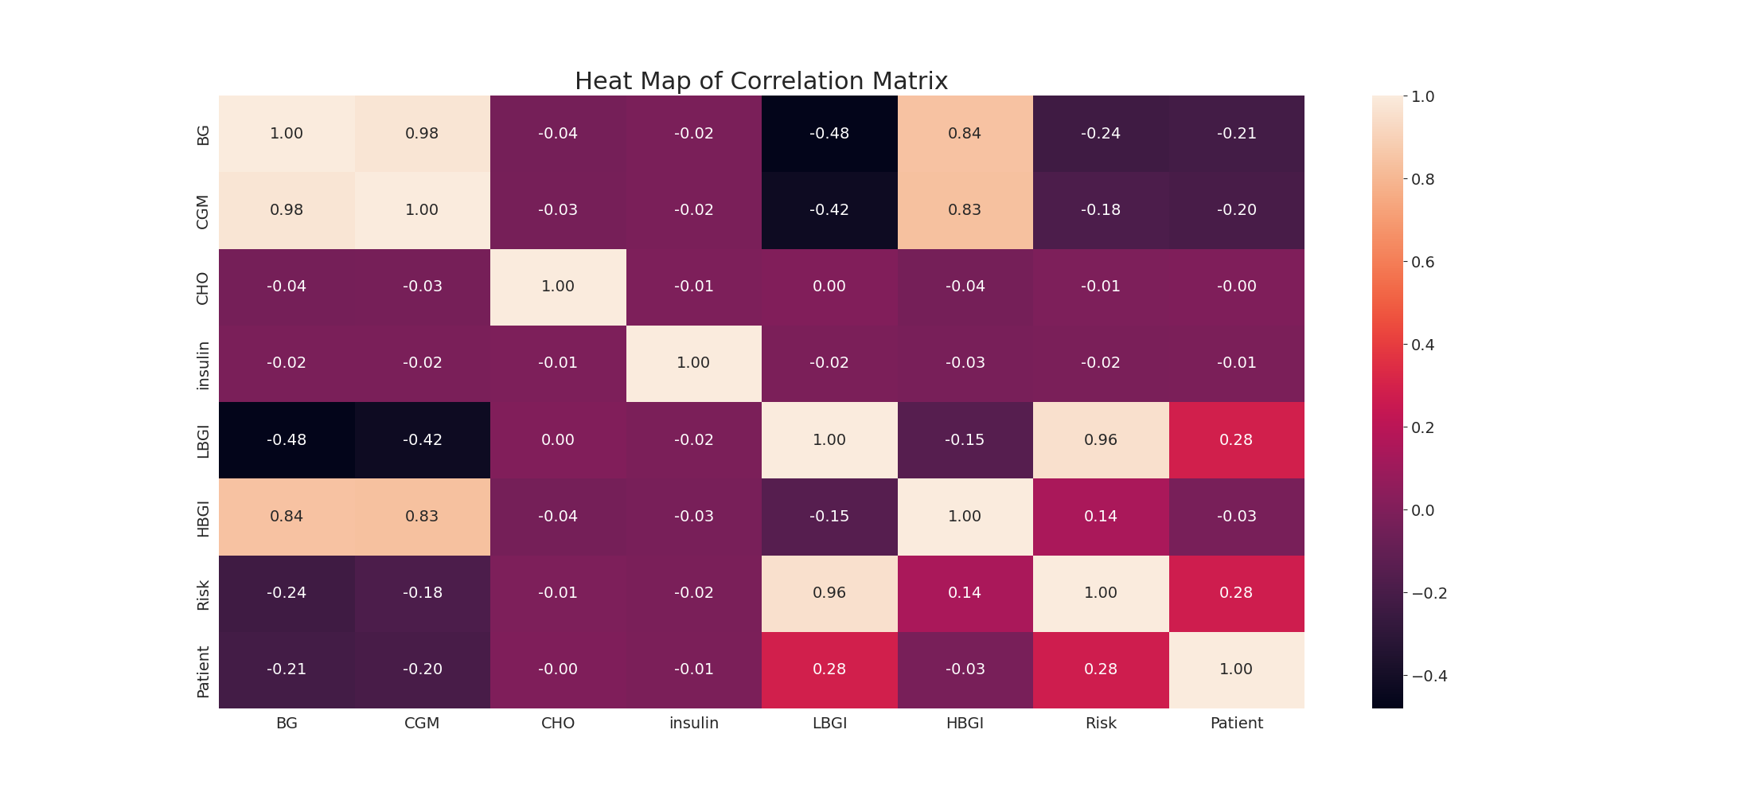

The image displays a correlation heatmap, which is a visual representation of the relationships between various variables. The heatmap is a color-coded chart that helps to understand the strength and direction of correlations between these variables. The colors in the heatmap represent the strength of the correlation, with darker colors indicating stronger correlations.  
  
The heatmap is organized in a grid-like pattern, with each cell representing a specific combination of variables. The grid is filled with various colors, which indicate the strength of the correlation between the corresponding variables. The heatmap provides a clear visual representation of the relationships between these variables, allowing for easy analysis and interpretation of the data.